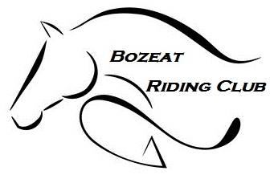
Newsletter
June 2018

Chairs Chat

What a month May was, with team's out competing and coming back with plenty of rosettes we could not be prouder. See team news for result.

June promises to be another busy and exciting month, we are very proud and lucky to be hosting an event at Aston le walls Beer and Gin festival......yes you read that right, Beer and Gin what more could you want? 16th and 17th June, day one arena eventing, day 2 show jumping, please see our Facebook and website for details. Also, some of our riders are competing at Ely horse trials qualifier 10th June, we wish them the best of luck.

I am proud also to say I have done it and am now a British Riding Club Official Steward.
Also, Amazingly I have a new horse that I am taking things very slowly with.
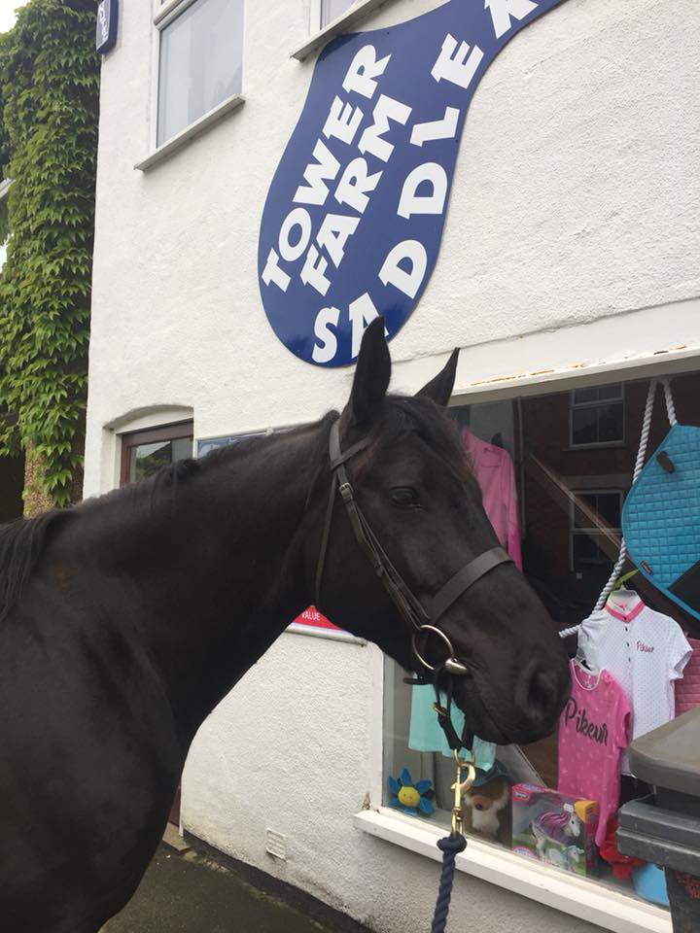
Meet Merlin doing a bit of window shopping

Summer is fast approaching and we have so much planned so please keep an eye on our Facebook like page https://www.facebook.com/BozeatRC or our group https://www.facebook.com/groups/bozeatrc

Kelly Bellham
Chairperson

if anyone can spare an hour or 2 at any of our events please email us at bozeatrc@gmail.com.

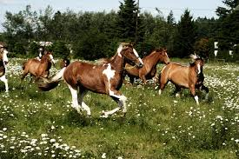
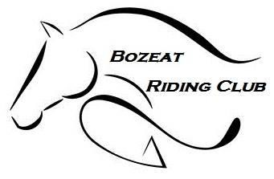
British Riding Club Area 7 Events

Hi all Members

Don’t be shy (our teams are doing very well this year)

Riders needed for Summer Showjumping qualifier at Whites Nurseries Earls Barton, Northampton. (On Grass)
£18.00 per class & £16.00 for junior Style jumping
Entries on line https://www.myridinglife.com/eventdetails.aspx?id=267960

Heights to suit all, 70cms - 110 plus Style Jumping 75cms or 85cms team and individual (Passport numbers and any SJ points will be required when booking in)

We are required to provide 2 helpers per team that we enter (usually for a couple of hours of pole picking or stewarding) So any volunteers for this would be gratefully received. Please email bozeatrc@gmail.com if this is something you could help with.

Show jumping training and Style Training OPEN TO ALL £30.00 for 90 min session for Members (you don’t have to be in the jumping team it is OPEN to all) Sat 30th June with Jonathan Canty (wonderful jumping instructor Who is the style judge on the day, we are giving you as much help as we can) Will do a 95cm training class if required just book in on the 85 and put in notes that you would like to do the 95cm please
online bookings https://www.myridinglife.com/eventdetails.aspx?id=267964

Any further information please feel free and Contact Team Manager Becky on 07968762192 via text or call early evening

COMPETITION | DATE | QUALIFER VENUE
Showjumping & Style Jumping | 08/07/2018 | Boughton HouseNN16 9XQ
Blenheim | 13/09/2018 | Blenheim Palace, Woodstock, OxonOX20 1PP
FOTH Hunter | 06/10/2018 | Keysoe E.C, Church Rd, Keysoe MK44 2JP

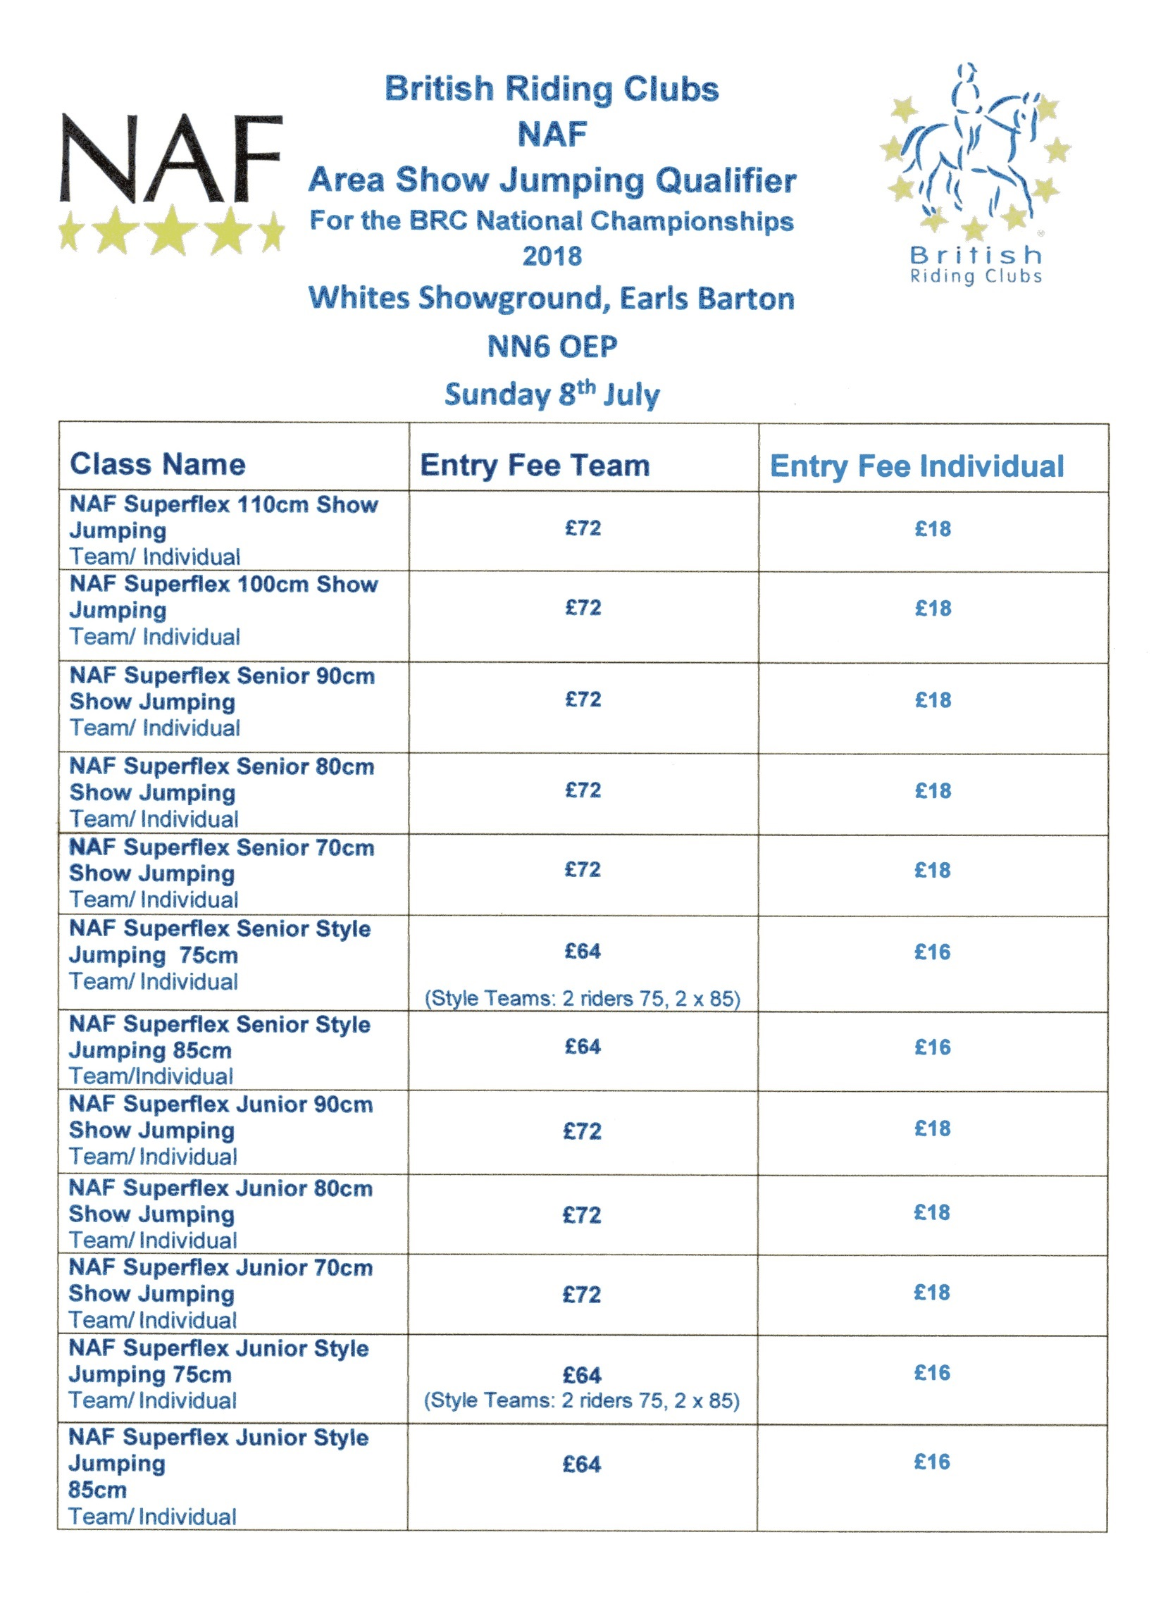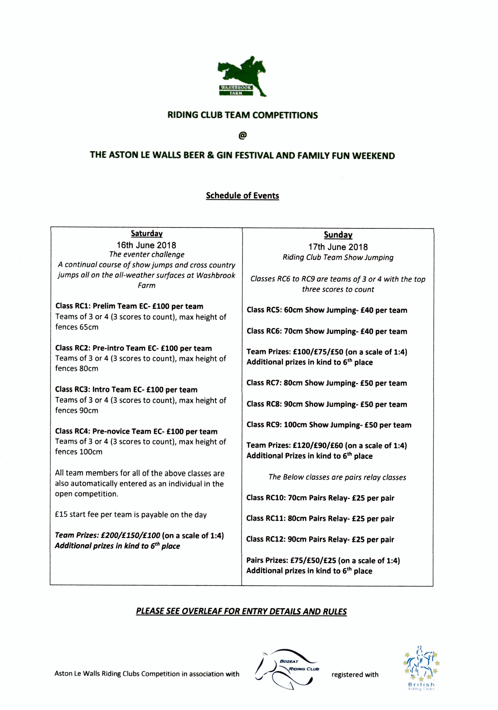Rockingham Internatinal
20th May

How prouder can we be of our amazing riders and their beautiful horses and
ponies, you showed what this club is made of, fantastic day and well done to RFRC
for a fabulous run event.

Bozeat Bounty's....placed 2nd in the team event, Kayleigh Manley 70cm, Emma Eales 80cm, Elise Kyle 90cm and Jodie Finch 100cm.
Bozeat Boost's....placed 5th in the team event, Cody Manley 70cm, Alice Spence 80cm, Chloe Alibone 90cm and Sarah Barrett 100cm.
Bozeat Buttons....placed 13th in the team event, Finley Wotton 70cm, Ebony White 80cm, Charley White 90cm and Myles Reeves 100cm
individual placings
Cody Manley placed 10th 70cm. Emma Eales placed 4th 80cm. Alice Spence placed 9th 80cm.
Elise Kyle placed 3rd 90cm. Charley White placed 8th 90cm.
Out of 41 teams and individual riders in each section you should all be very proud of your selves just like we are of you all.

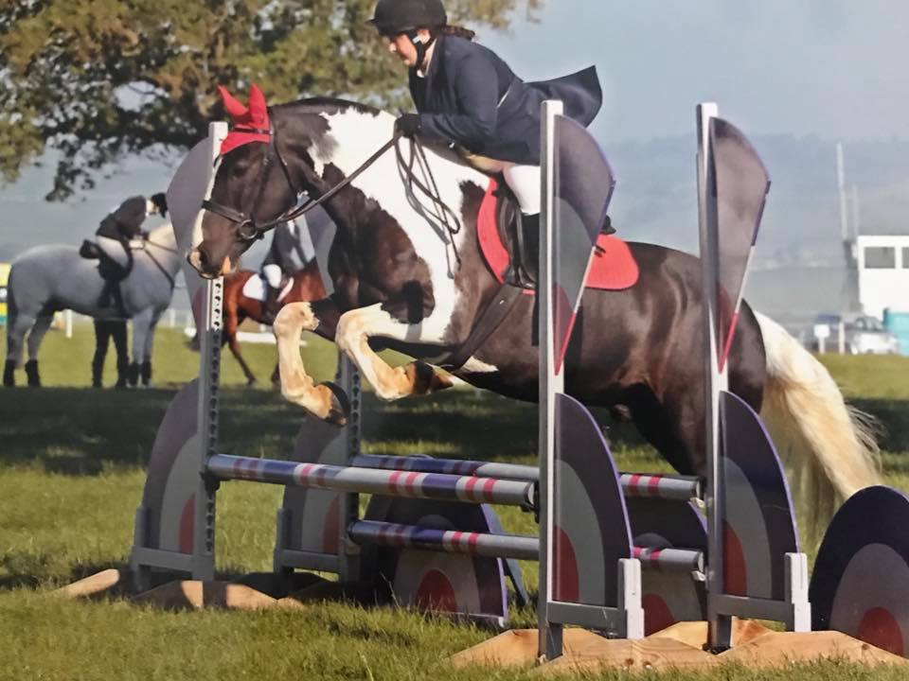
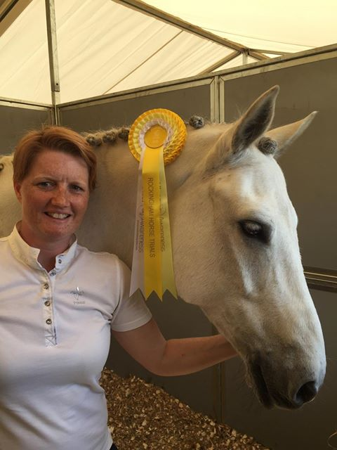

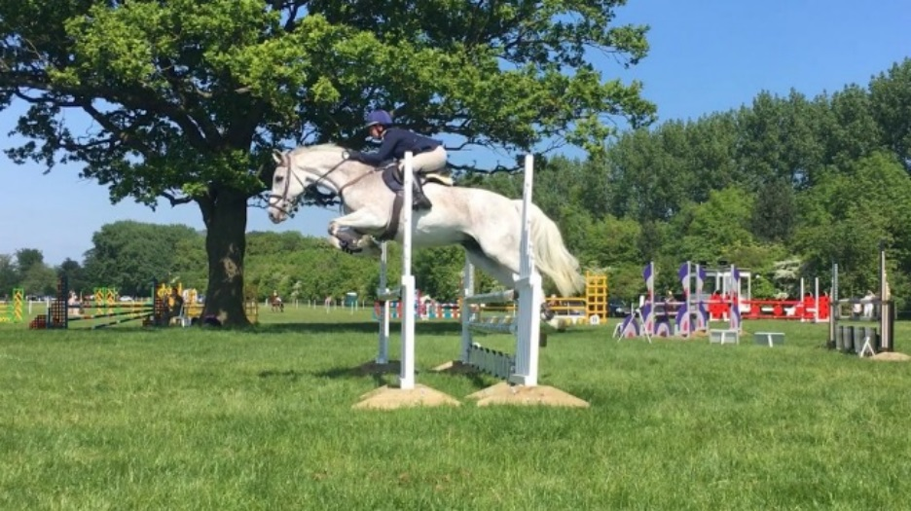

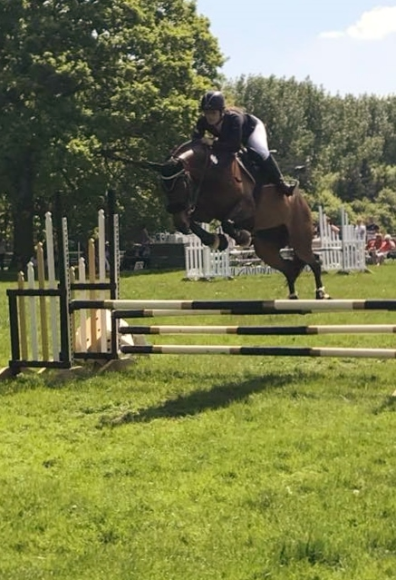
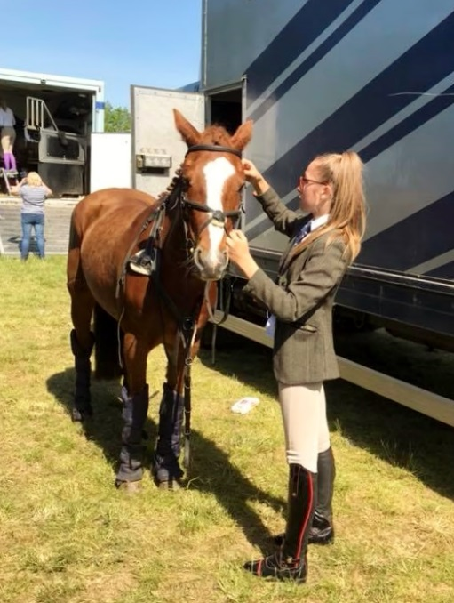
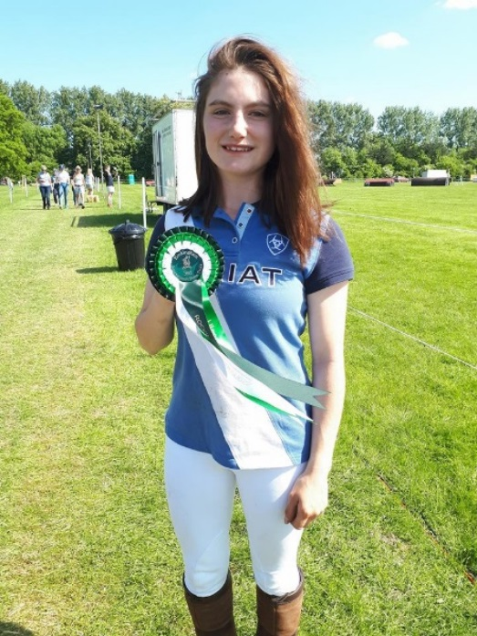
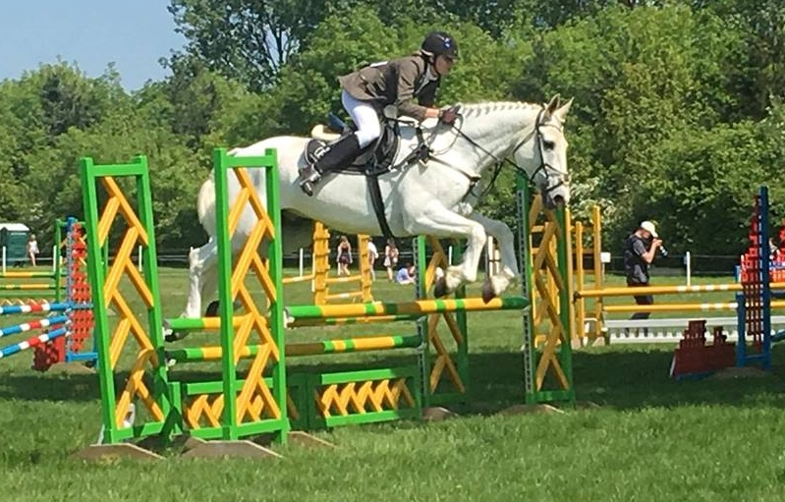
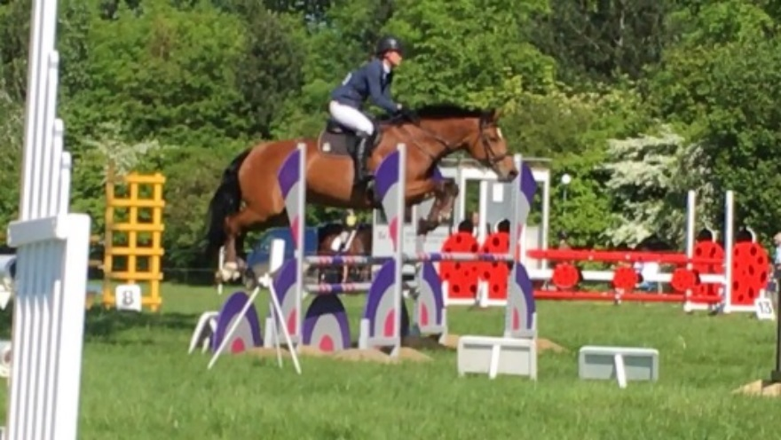

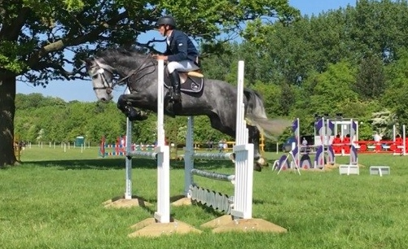
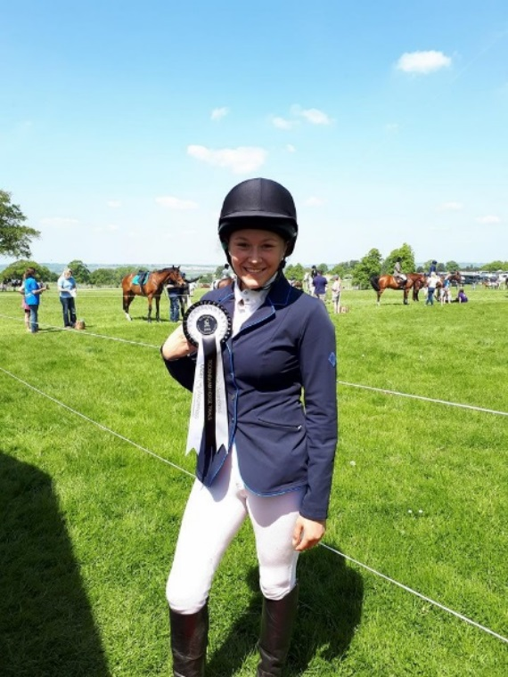
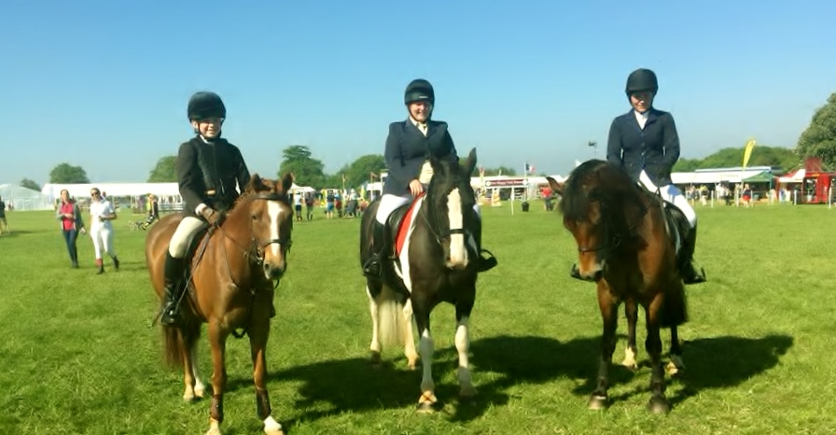
2 Day Event
26th & 27th May

Well Stoneleigh riding club do know how to put on a fantastic event.
we entered two teams & and Individual
80 Team
Kayleigh Manley, Cody Manley, Kelly Brown and a Houghton & Huntingdon Rider Katie Larman.
90cm Team
Jodie Rea, Elise Kyle, Claire Ludeks.
100cm Ind
Claire Ludeks.
A Huge thank you to Clare Kyle for organising you all for the weekend and not forgetting Louise Kyle for taking over 500 Photos of our teams.
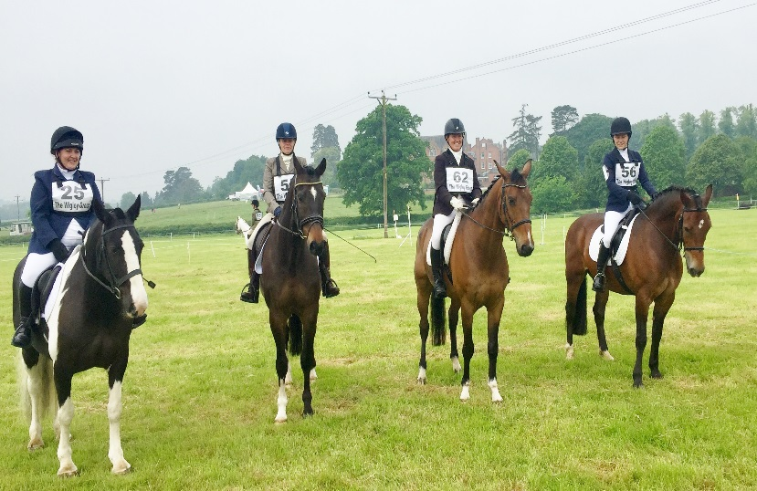
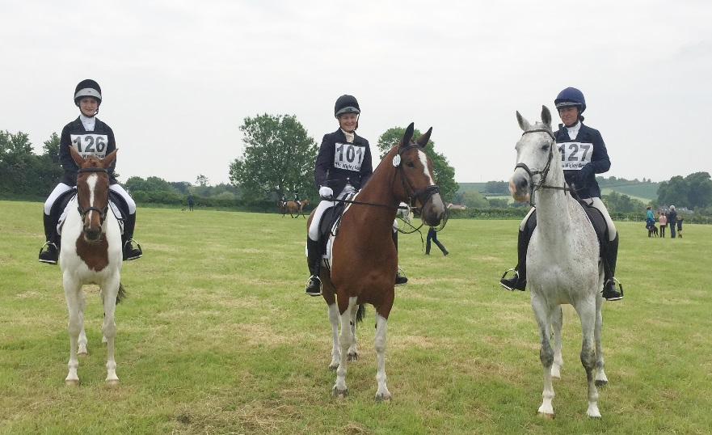
Dressage Day 1

Rider | Horse | Total | Place
Katie Larman | Wolferlow Park | 33 | 5th
Kayley Manley | Archie | 227.5 | 22nd
Kelly Brown | Rasputin | E
Cody Manley | Flyer | E
 |  | Team | E

Rider | Horse | Total | Place
Claire Ludeks | A Shot in The Dark | 34 | 11th
Jodie Rea | Cavallo III | 43.8 | 9th
Elise Kyle | Sizzing Sophie | 46.2 | 11th
 |  | Team | 5th

Rider | Horse | Total | Place
Claire Ludeks | Ellis Duke | 43 | 4th
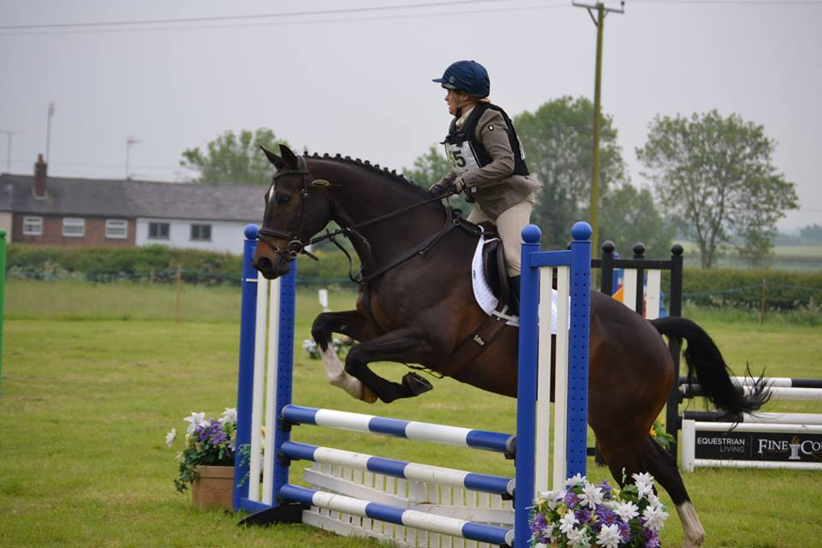
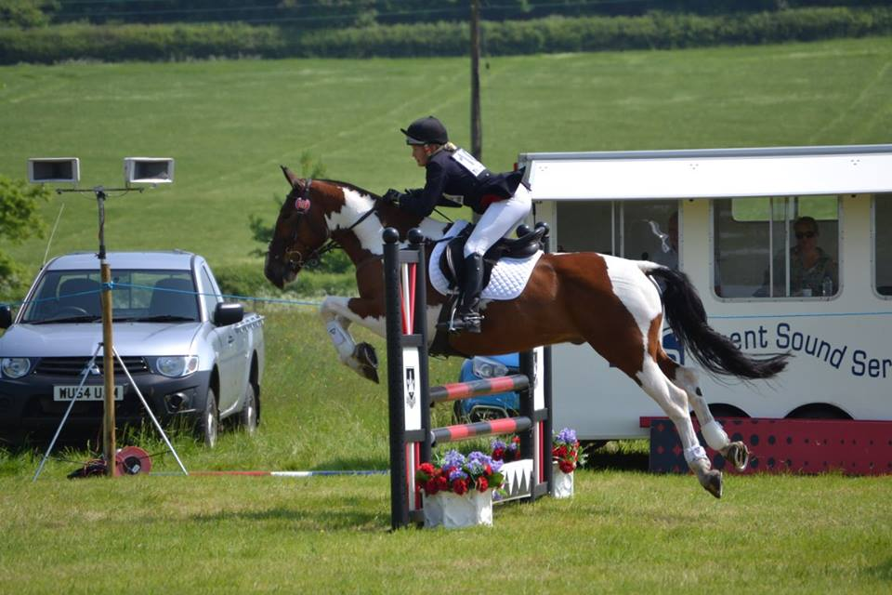
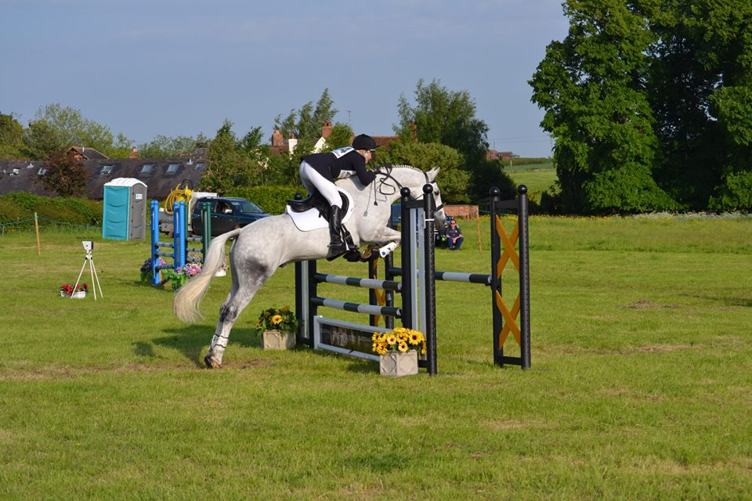
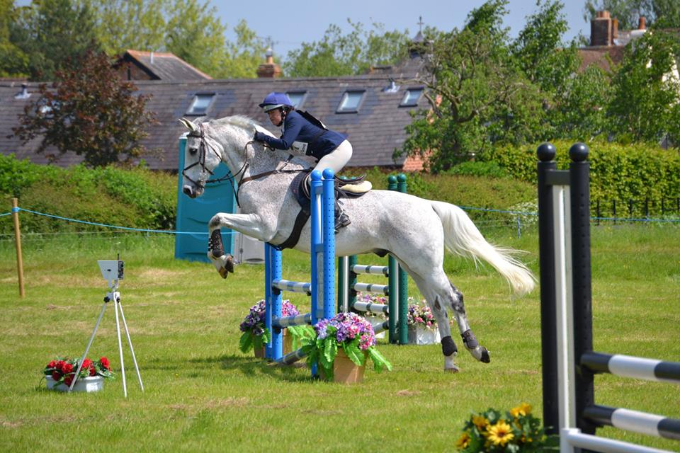
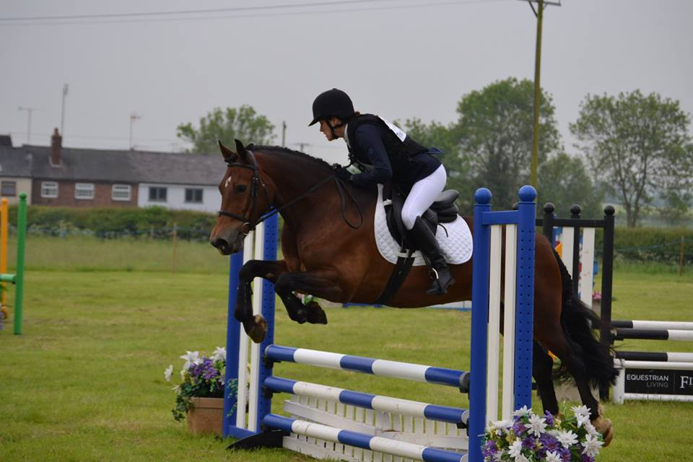
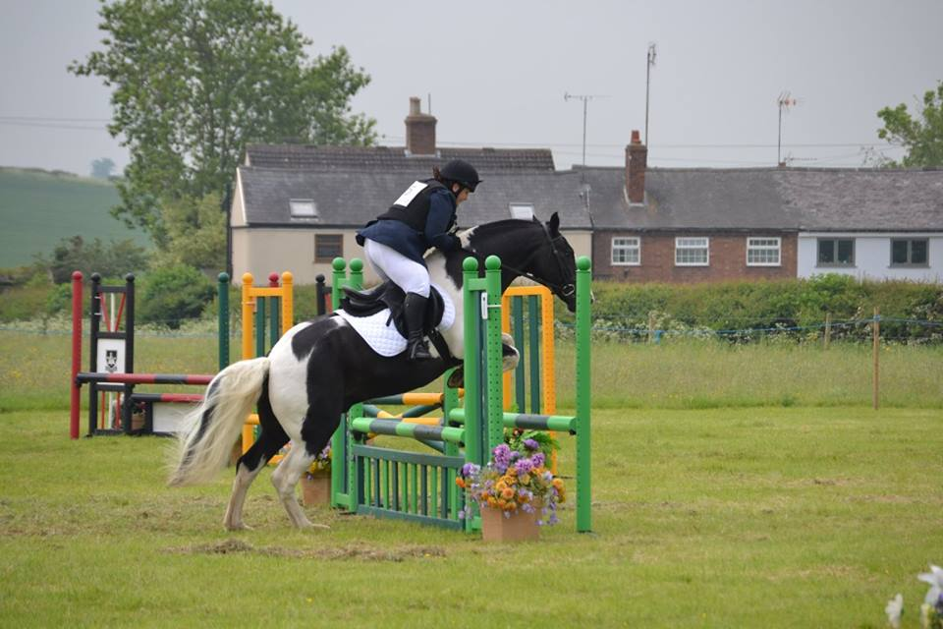
Show Jumping Day 1

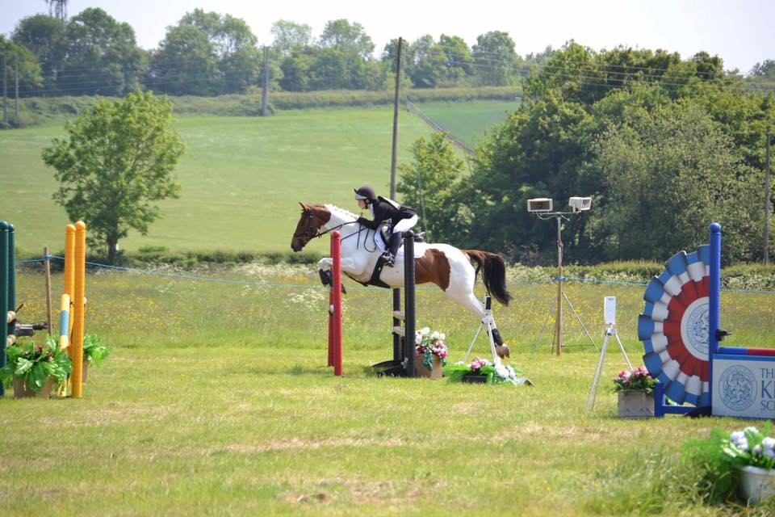

Steeple chase & XC Day 2
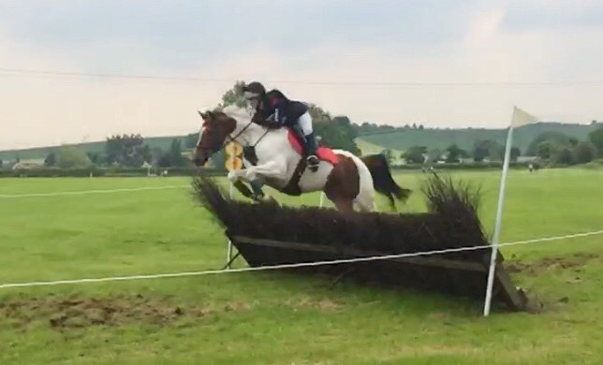
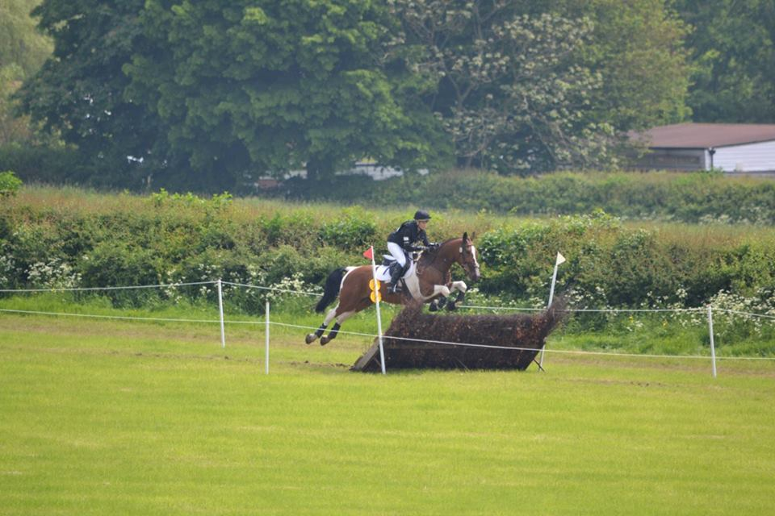
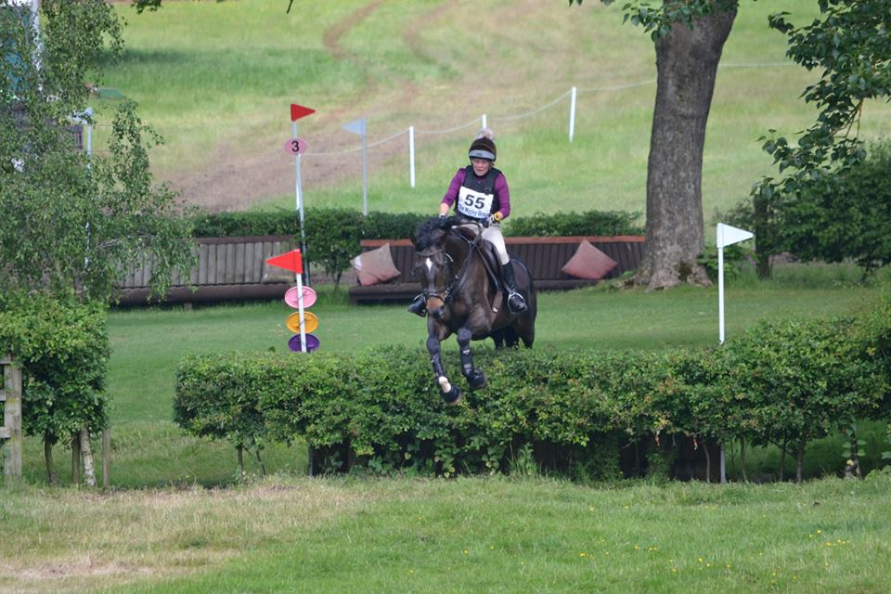
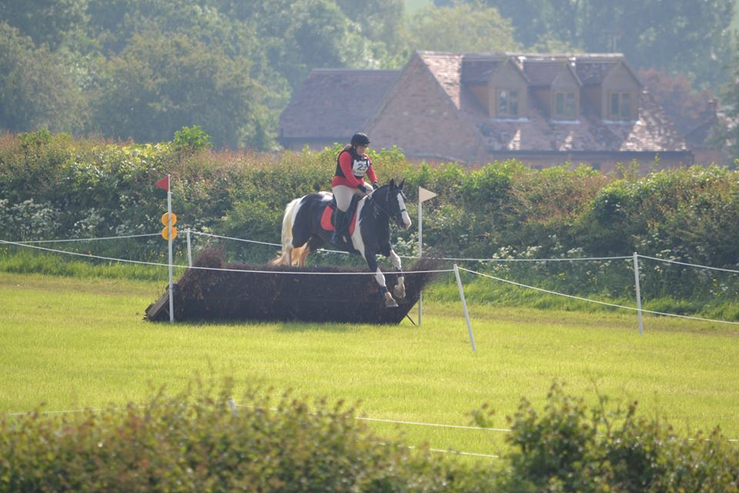
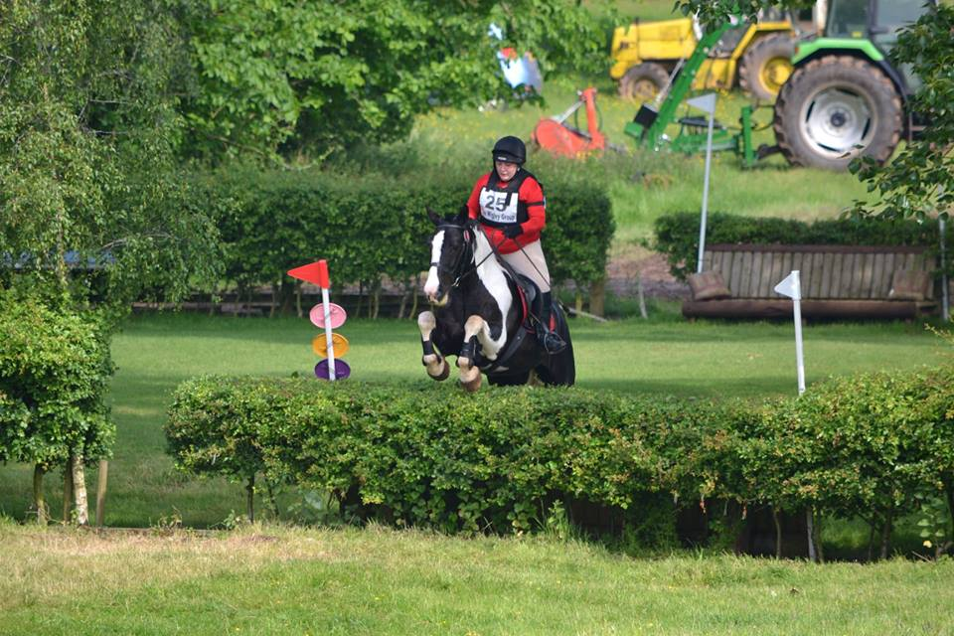
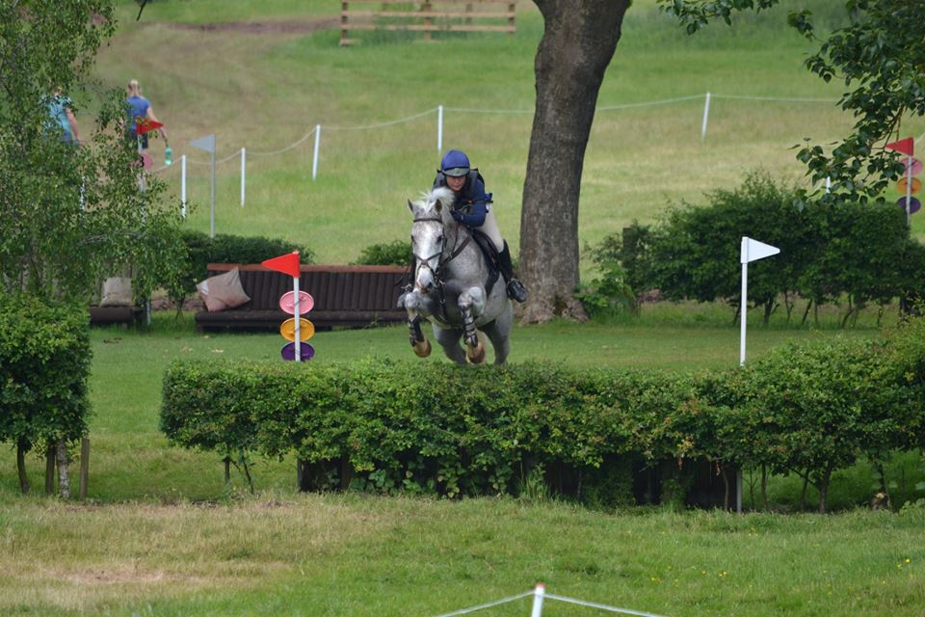
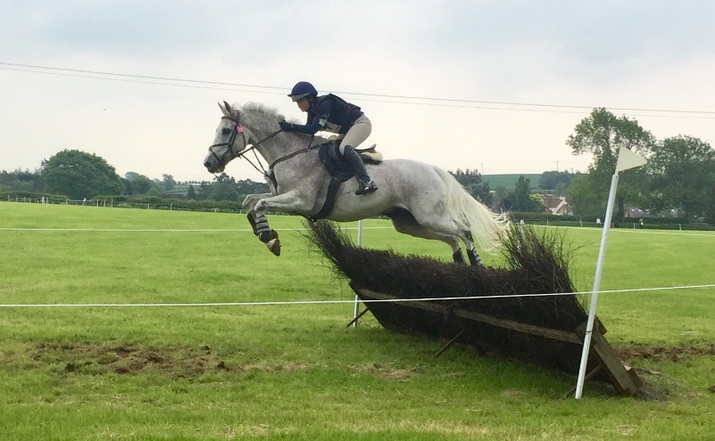
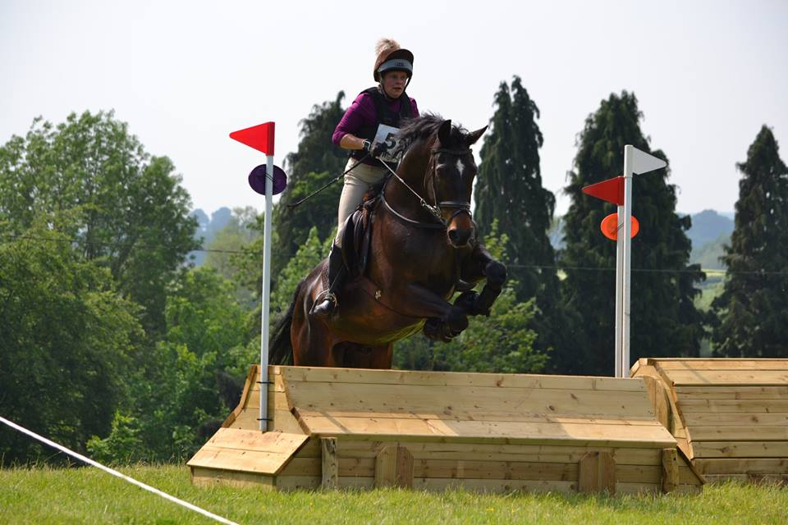
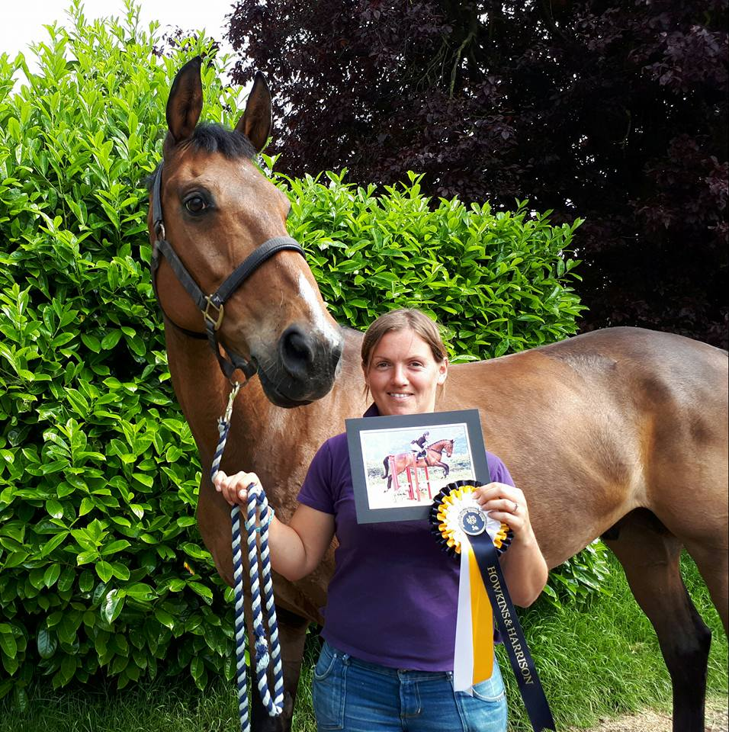
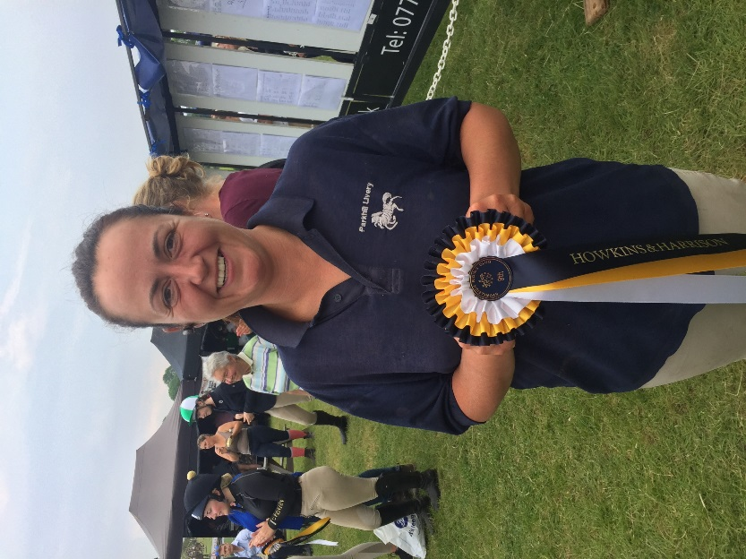
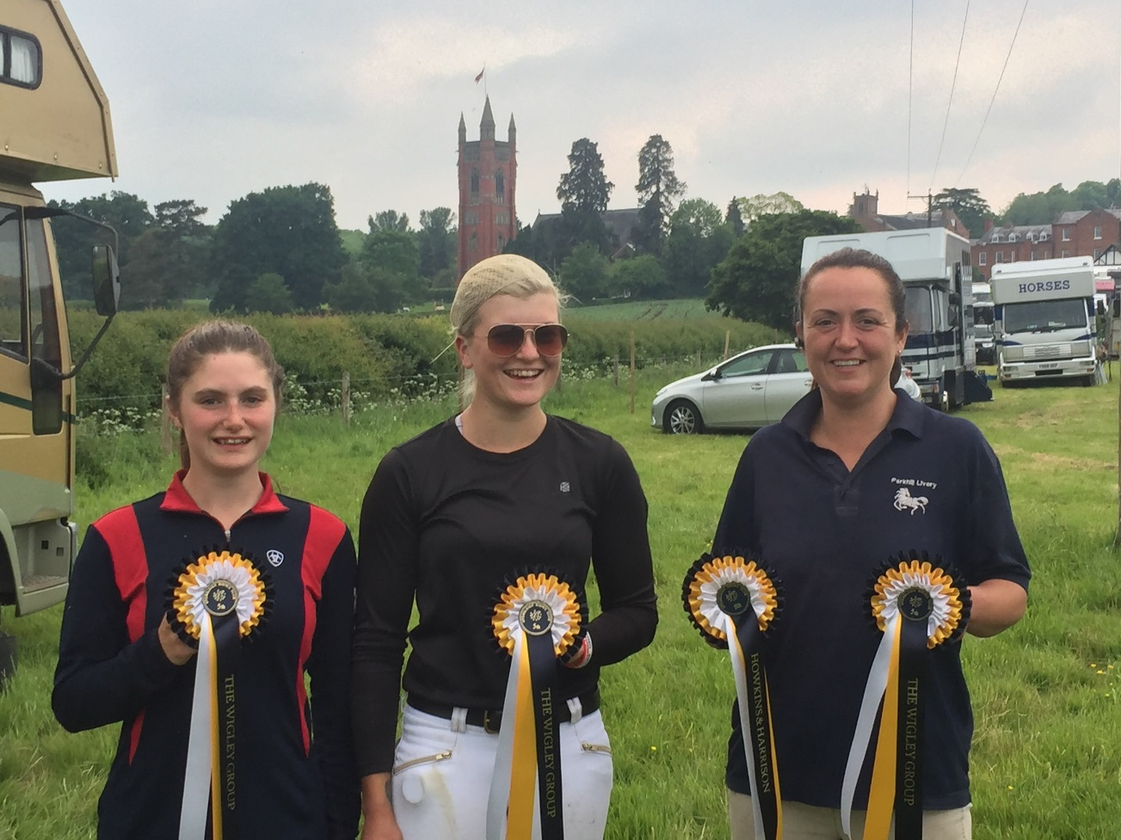

Photos from Louise Kyle
www.facebook.com/L-K-Photos-416321242165500
Training Calendar 2018

X C
Sat | 14 | July | XC Training MK | Jo Burchell | MKEC
Sat | 11 | August | XC Training Glebe |  | Glebe Farm E.C
Sat | 8 | Sep | XC Training Glebe | Tom Fray AM | Glebe Farm E.C
Sat | 15 | Sep | XC Training Glebe | Jo Burchell | Glebe Farm E.C
Glebe Farm XC training venue may be changed depending on our course being built
Show Jumping
Sat | 30 | June | Show Jumping & Style T | Jonathan Canty | Glebe Farm E.C
Sat | 21 | July | Show Jumping Training | Tom Fray AM | Glebe Farm E.C
Sat | 25 | August | Show Jumping Training | Tom Fray AM | Glebe Farm E.C
Sat | 29 | Sep | Show Jumping Training | Tom Fray | Glebe Farm E.C

Ride a test
Sat | 4 | August | Schooling with Poles | Kate Davis | Glebe Farm E.C
Sat | 4 | Sep | Schooling with Poles | Kate Davis | Glebe Farm E.C

Open to Members and Non-members on line Payments and entry fees
https://bozeatrc.wixsite.com/bozeatrc/brc-events
Hi guys, unfortunately we didn’t squeeze any training in this month but we are looking to adjust a few to gain more interest and create more success.
I’d like to take this chance to share the experience I had at the 2DE at Princethorpe College last weekend with Bozeat riding club. I’m not going to lie when I was persuaded to enter I was absolutely petrified. The whole thing, from start to finish! We had rented stables nearby which made the whole experience much more relaxed and enjoyable. This was organised by Bozeat RC which made the planning and organisation so much more chilled.
Having never done an event like this before I wasn’t sure what to expect. I was completely overwhelmed with the whole experience, from preparations, stabling, support, emotions, competing and results!!! It really was an experience I’ll never forget and that isn’t because it was my first 2DE… honestly it was down to Bozeat Riding Club. They helped and supported both me and my sister (who also competed) along with the other riding club members (who were fantastic too!). If anyone likes to go out and have some fun, perhaps you’re indecisive on team events… honestly, I really would say GO FOR IT! I can hand on heart say you will not be disappointed in the experience you will have with us! Kayleigh
Kate Davis
pole work clinic
Saturday 4th August
Saturday 22nd September
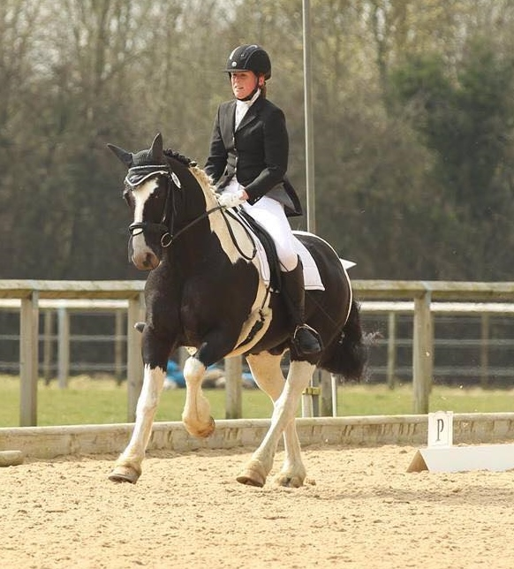
Demand is high for these ‘Pole work Clinic’ dressage clinics with British Dressage judge list 5, Kate Davis.

Pole work for Dressage clinics are designed to be a bit different from regular flat work training. The introduction of poles often gives the horse and rider more to focus on and a better awareness of accuracy, space and effectiveness of the aids.

It can often liven up a flatwork session for horses that switch off in the school, and gives nervous horses and riders something to think about, which results in a more productive schooling session
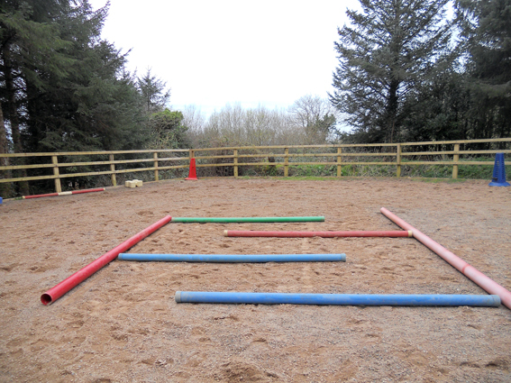
Clinic Choices
Introduction to poles
Walk & Trot Poles
Walk & Trot & Canter Poles
one-hour Session
£25.00 Bozeat Members
£30.00 Non-Members
Times available from Thursday before the Event
Kind Permission of
Harrold Rd, Bozeat, Wellingborough
NN29 7LB

On line entry Via our website https://bozeatrc.wixsite.com/bozeatrc/brc-events
Jonathan Canty
Jumping & Style Jumping

Saturday 30th June

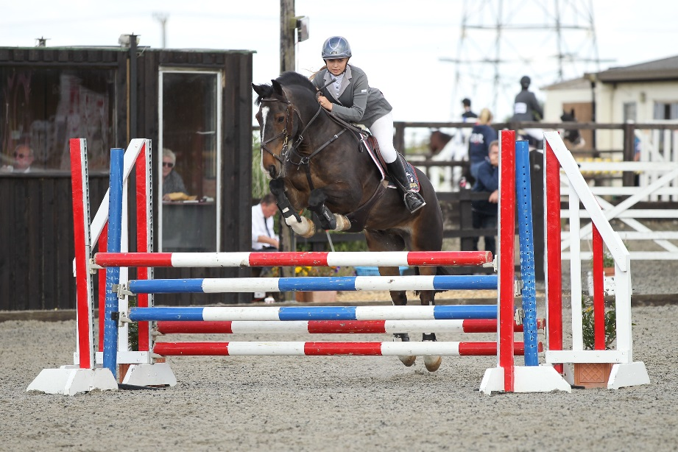
Final preparations for style jumping & Showjumping from British Riding Clubs style judge Jonathan Canty.

This clinic allows you the opportunity to discover what is expected of them and their horse or pony should you like to take part or have entered in a BRC Riding Test competition.

It doesn't matter if you are an experienced competitor in this discipline or you are new to them - why not give it a go and get involved.
90 min Session
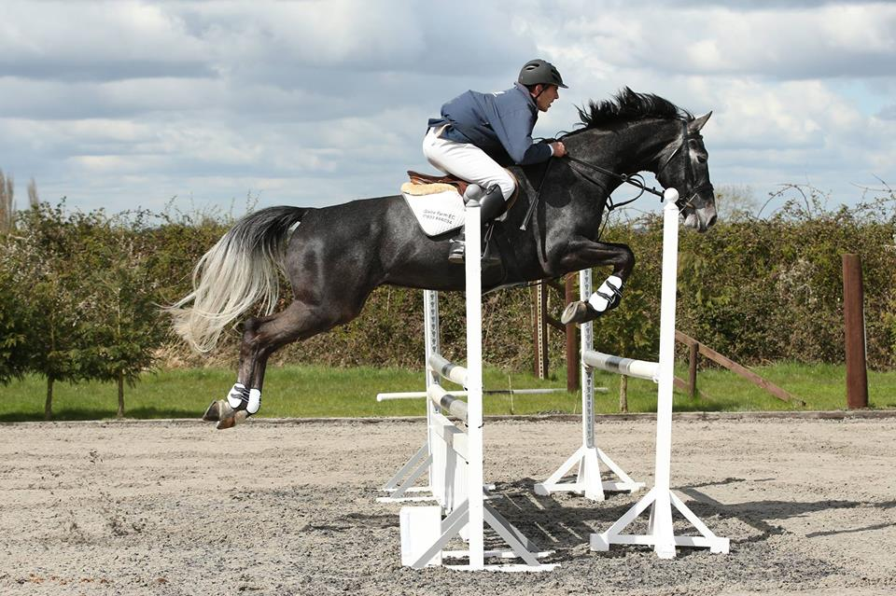
65cm
75cm
85cm
Will do 95cms if required

£30.00 Bozeat Members
£35.00 Non-Members
90 min session, groups of no more than 4 in a group

Entries close Wednesday 27th June times available Thursday

Kind Permission of
Harrold Rd, Bozeat, Wellingborough
NN29 7LB

On line entry Via our website https://bozeatrc.wixsite.com/bozeatrc/brc-events
Sponsors

Bozeat Riding Club would love to thank all our sponsors
Winter Show Jumping

Winter Dressage

For all your sponsorship needs please contact
our lovely Emily Platt
Via Email emily.g.platt95@hotmail.co.uk
Advertising Sponsors

Club Events

Dressage

We had no dressage in May but look forward to seeing our dressage riders back with us from June. All future dressage competitions will be qualifiers for Great Midlands Horse show.

Show Jumping 27th May
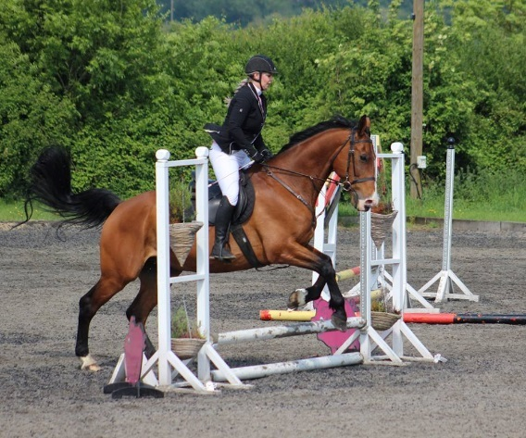
What a fantastic day’s show jumping, so many clear rounds in very fast times, all clear rounds were eligible for qualifier card to the Great Midland Horse Show, all future shows will also be qualifiers except the 40cms and the derby classes. Even Terri who has never taken part in jumping before has a go well done darlin we will make a show jumper out of you yet. Also, the fun derby was fun well done everyone that took part in them classes.
A huge thank you to all our volunteers with out them shows would be very hard to put on. If you can help at our next show jumping 17th June please contact the club bozeatrc@mail.com

Photography
Charlie White – Miss Northamptonshire will be at most of our shows providing memories for you to keep. See her Facebook page for your images
www.facebook.com/cswequestrianphotography

Open
Dressage
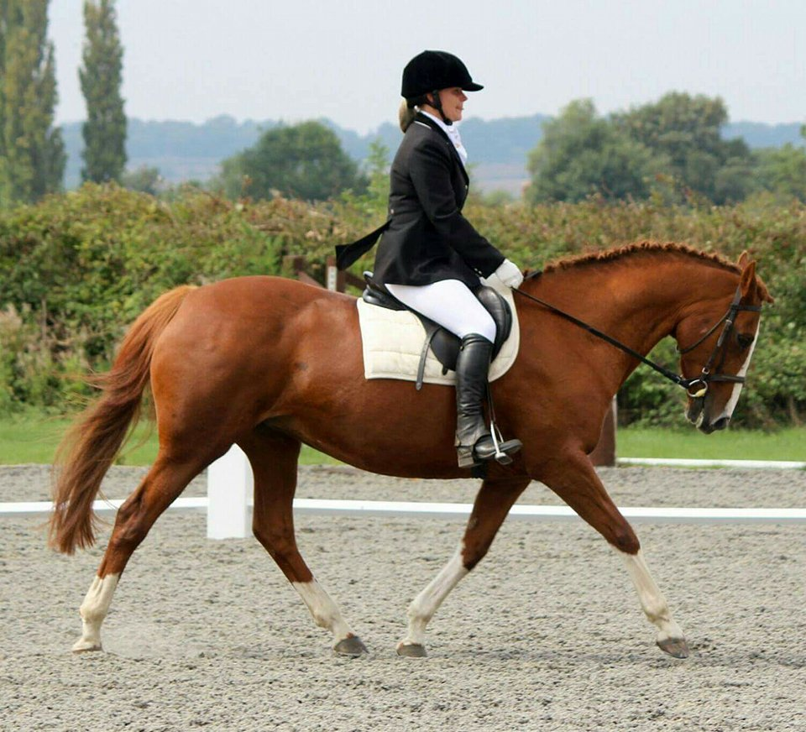

Sun 3rd June 2018
Sun 15th July 2018
Sun 12th August 2018

£12.00 for Bozeat Members
£14.00 for Non-Members

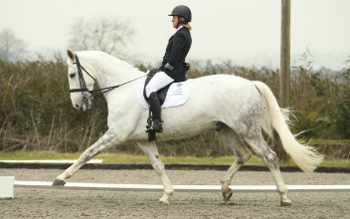

Classes
Intro A (2008)
Intro C (2016)
Prelim 2 (2016)
Prelim 13 (2006)
Novice 24 (2010)
Novice 27 (2007)
Elementary 42 (2008)
Pick a test - Prelim 7, Novice 28, Novice 34

Horse & Rider combination
must gain one score of 60%
to qualified at each Level

Kind Permission of Kindly Sponsored By
Harrold Rd, Bozeat, Wellingborough, NN29 7LB
Open
Show Jumping

Sun 17th June 2018
Sun 29th July 2018
Sun 16th September 2018

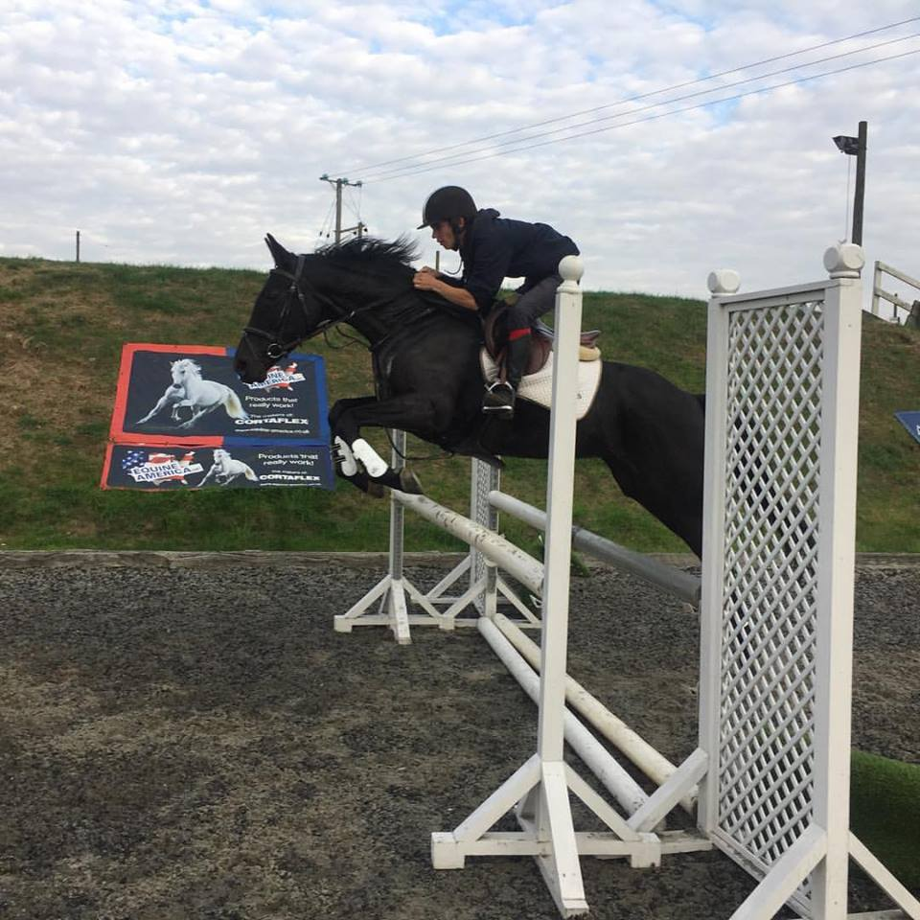

Classes
Class 1 40cms
Class 2 50cms
Class 3 60cms
Class 4 60-70cms
Fun Derby jumping
Class 5 70-80cms
Fun Derby jumping
Class 6 70cms
Class 7 80cms
Class 8 90cms
Class 9 100cms
Fun Derby Depends on ground conditions

£8.00 for Bozeat Members
£10.00 for Non-Members
On the Day with a £2 surcharge per entry
Kind Permission of Sponsored By
Harrold Rd, Bozeat, Wellingborough
NN29 7LB
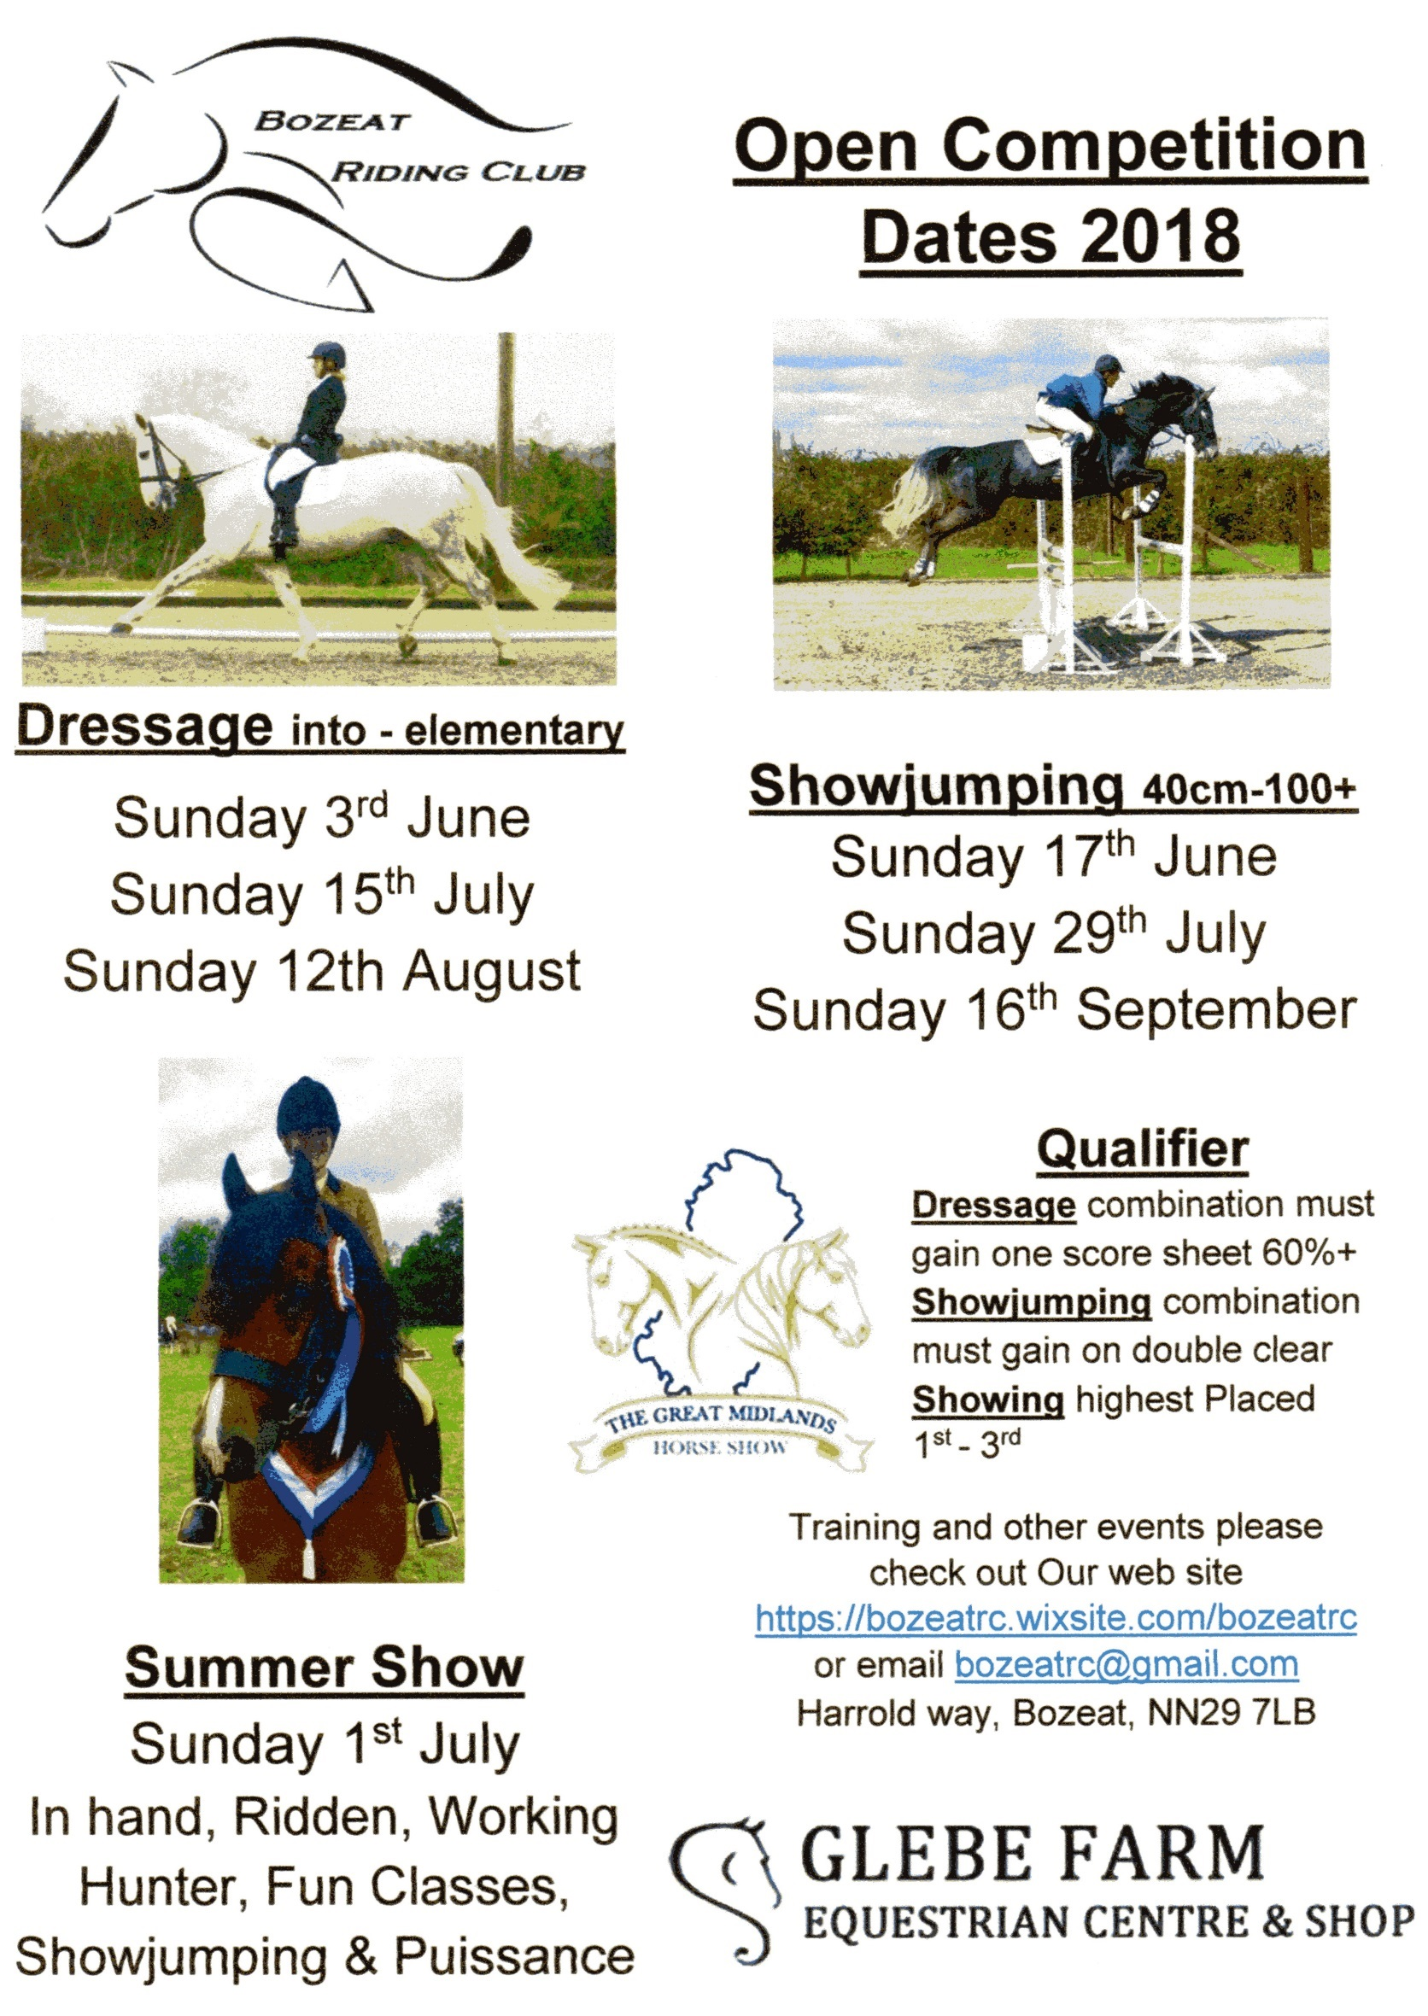
Your committee

Role | Name | Email | Phone
Chair | Kelly Bellham | kellybellham66@hotmail.co.uk | 07867424022
Vice Chair | Roger Batten | roger1batten@gmial.com
Secretary | Terri-Marie Freeman | terrifreeman09@live.co.uk
Treasurer | Alex Hadland | alexandrahadland@gmail.com
Team Manager | Rebecca Hall | rebeccahall2704@yahoo.co.uk | 07968762192
Other Teams | Clare Kyle | clarekyle73@gmail.com
Area Rep | Rosemary Batten | rosebatten@aol.com
Training Co-ordinator | Kayleigh Manley | kayleighmanley94@hotmail.co.uk
Training Co-ordinator | Hayley Wright | hayleymaywright@hotmail.com
Health & Safety | Michelle Hicks | ladymichellehicks@gmail.com
Website & Media | Caryn Harris | carynharris@hotmail.co.uk
Sponsorship | Emily Platt | emily.g.platt95@hotmail.co.uk
Dressage Secretary
Showjumping Secretary | Helen Tyler | helentyler2013@hotmail.co.uk
XC & Showing Secretary

https://bozeatrc.wixsite.com/bozeatrc/brc-events
Please contact bozeatrc@gmail.com for further information

Membership Application

Personal Details | Please fill in below
Title and first name
Surname
Address

Postcode
Contact telephone number

Email address
Next of kin contact
name and telephone number
Date of birth if Junior membership
Which disciplines are you interested in? | Please fill in below
Teams, Training, Le Trec, Dressage, Show Jumping, Horse Trails, Combined Training, Cross country, Quadrille Dressage to music-
or anything else we may not yet be involved with

We cannot run events without volunteers, please indicate at which events you will be able to volunteer. 4 hours help as condition of membership Please fill in below
For example:

Course Building, Poll Picking, stewarding, dressage writing, Scoring, setting up the day before, dismantling
Please send Form and Correct fees to | Members Subs
Cheques made payable to: -  Bozeat Riding Club  Glebe Farm E.C, Harrold Rd,  Bozeat, Wellingborough, NN29 7LB  Email: - bozeatrc@gmail.com  Membership will only be accepted on receipt of membership form and payment  Membership Runs for  1st January – 31st December | Senior Member £25.00  Junior Member £23.00  Non-riding Member £12.00  For bank Transfer Details Please  Email: - bozeatrc@gmail.com

